Robotics

**Unit 2 User’s Guide**

Introduction to Programming

horizontal line

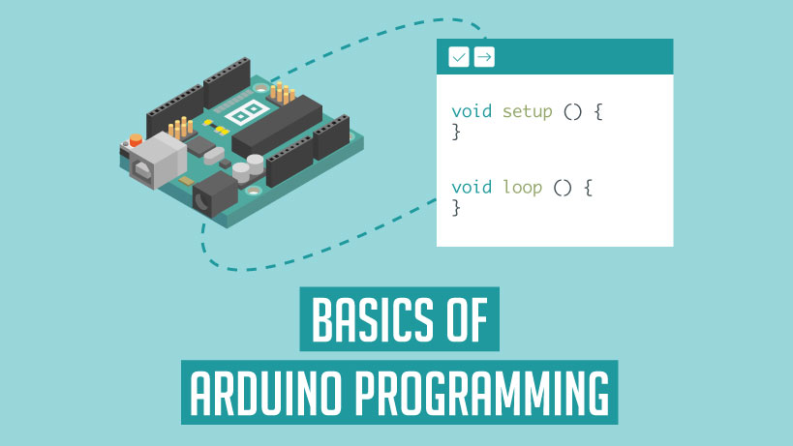

**Ctrl+Alt+Elite**

**CONTENT OF UNIT 2 SLIDES**

**Unit 2 : Introduction to programming**

**Section 1: Programming Concepts**

* In Depth Variables
  + Types
  + Uses

**Section 2: Introduction of Programming Structures**

* Sequence
* Repetitions
* Selections

**Section 3: Statements**

* If-Statements
  + Why Use Them
  + Names
  + Project
* If-Else Statement
  + Why Use Them
  + Names
  + Project

**Section 4: Programming in Atom**

* How to use Atom

# 

# OVERVIEW

# This unit is a basic introduction to programming. Students will learn the foundations of to write a well structured code.They will explore logic and problem solving. Student will learn about different variable types and how they are declared. Student will also learn how to construct and create loops. At the end of this unit students should be able to declare variables, create if-statements and create program in Atom. Students will learn to code in Atom. This unit contain several activities that illustrated the above descriptions.

# FOCUS STANDARDS

# From our experience implementing this unit, we have selected the following focus standards.

* Describe programming structures
  + Sequence
  + Repetition
  + Selections
* Introduce programming logic
  + Different types of approach
    - Top-Down Approach
      * Starts with the big picture and break it down into small steps.
    - Bottom -Up Approach
      * Putting together a picture to give rise to a more complex picture.
* Introduce the different types of variables used in this unit.
  + Why and When variable integer (int) is used
  + Why and When variable boolean (bool) is used
  + Why and When variable Double (double) is used
  + Why and When variable String (string) is used
* Explain If-Statements.
* Explain If-Else Statements
* Describe Atom and why it is used in this unit to write codes.

# OBJECTIVES

These set objectives are to be checked at the end of this unit. Students should know the minimum of the following objectives to move forward. Students should learn, understand and how to implement the following:

* Programming concepts
* If-Statements
  + If-Else Statements
* Basic Variables
  + Integers
  + Booleans
  + Double
  + String
* Write a program in Cygwin

# SAMPLE ACTIVITIES

The activities listed below are to completely by the end of this unit. All of them are build using materials leaned in this unit.

* Declaring different types of variables
  + Variables of type integer
  + Variables of type Boolean
  + Variables of type Double
  + Variables of type Character
  + Variables of type String
* Construct Pseudo Code
  + Get a detailed step by step explanation of how to “Bake Bread”.
    - Or any other tasks that involve multiple steps.
* Create the following Loops
  + While loop
  + Do While Loop
  + For Loop
* Build and create a program in Atom

**BILL OF MATERIALS**

* **List of Materials needed for this unit (per student)**
  + Laptop
  + Download and Install Atom
  + Download and Install gpp-compiler package for Atom
  + Download Install MinGW

# INSTRUCTION ON DOWNLOADS

You will need an IDE and a g++ compiler for C/C++ coding

1. Install Atom
   * <https://atom.io/>
2. Install gpp-compiler package for Atom
   * <https://atom.io/packages/gpp-compiler>
3. Install MinGW
   * <https://osdn.net/projects/mingw/releases/>
   * Select **mingw-get-setup.exe** (Should have a blue icon next to the text to click on)
   * Install MinGW under C:\MinGW
   * Install mingw32-gcc-g++-bin

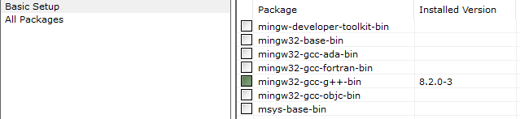

1. Set the environment variables for the PATH of mingw
   * Guide: <https://www.rose-hulman.edu/class/csse/resources/MinGW/installation.htm>

You should now be able to run Atom and compile a .ccp file using F5